







# Title Gradient 6Chapter Section

Miau miau miau.

## Who Is This for

This book is intended for beginner Game Master and players who have never played QuestGuard.

## What To Expect

Fire on Mount Hyhelm follows a group of 3 to 5 players, on an adventure that will last one single session, start to finish (3 to 5 hours). Of course, you can do the adventure in multiple sessions, depending on the time you want to spend playing.

As a Game Master, you are **not required to read this book in advance**. Fire on Mount Hyhelm was made to be **read at a glance** - it requires minimal preparation. However, please read everything up until Chapter 1

before you begin, to learn how to use this book. Once you get to Chapter 1, simply let the book guide you.

The book contains many read-aloud sections, and flows top-to-bottom, left-to-right and will guide you through everything you need to say and do.

This adventure also teaches the players the basic rules of QuestGuard.

## Your Responsibility

As a Game Master, you will be the narrator and referee of the game. You present situations, and players will try to do things in those situations. A lot of the times, a **Check** is required (a roll of a die) to determine if the player succeeds in their action.

You will be responsible for reading passages out loud for your players, roleplaying as non-player characters (e.g. speaking in the voice of another character or conveying what they are saying), controlling the monsters in fights (e.g. rolling dice for them) and, usually, making sure every player gets their time in the spotlight and is having a good time.

# Title Gradient 6How to Read It

This section explains how to read the book and interpret the various elements.

## Read-Alouds

When you encounter text with a tan background like this one, read it out loud for the players. For example:



*You come across a narrow river that blocks your*

*path forward. The river smells of salt, thick muck*

*flows through it. What do you do?*

There will be a lot of these and they will narrate not just story elements, but also rules.

As a Game Master, **a lot of the information you have is from read-alouds**. These read-alouds will serve as information for both you and the players.

## NPC Replies

In some sections, NPC’s (non-player characters from the story) will have potential replies to say. Here is an example for a random peasant players encounter:



***“****Welcome to our village, adventurers!”*

***“****You look hungry. Head over to the tavern, they*

*serve good food!”*

***…****I did see* ***a strange man******in the******woods*** *last night!*

*…No, I never* ***stole*** *anything in my life! [lie,*

*he stole coins from the church donation box]*

You will see read-alouds with NPC replies.

The first few lines, in quotes, are dialogue lines meant to be **said directly** by the NPC (e.g. casually mentioning them in a conversation). For example, say the first dialogue line, wait for the players’ response, and if you see fit, say the next dialogue line. Rinse and repeat.

Lines starting with **…** are meant to be **only answers to questions** players ask, and should not be given without being asked specifically about the subject.

**Bold** phrases or words are emphasized to easily come into your view in case players ask about it.

If an NPC has no dialogue lines about a subject, then they don’t know about it.

## NPC’s - When In Doubt…

When in doubt of what an NPC would say, resort to them saying *“I don’t know” or a similar reply*.

Don’t worry - you will get good information on NPC’s that is easily readable at a glance, without requiring preparation. Feel free to paraphrase NPC dialogue lines.

## Suspicion (0 to 20)

Each NPC has a secret **Suspicion** level from 0 (is completely friendly and trusts the players) to 20 (will not even talk to the players or is outright hostile).

Whenever the players try to persuade an NPC and the NPC isn’t sure of what to do, have the players roll a Charisma Check at least equal to the NPC’s Suspicion.

On a successful Check, decrease **Suspicion** by 1. Otherwise increase it by 1.

If players say something insulting or fitting to the conversation, increase or reduce Suspicion by 1.

Keep track of the NPC’s **Suspicion**.

Depending on how mild or crazy the player’s idea is, feel free to secretly give a +5 or -5 to their Check.

Decreasing **Suspicion** will unlock certain dialogue lines

# Title Gradient 6Locations & Sections

The book’s chapters function as Locations.

Each “chapter” is a separate Location that contains read-alouds, artwork, scenarios, etc.

Here is an example:

# Title Gradient 6The Windmill

*As you ascend the winding cobblestone path, you*

*approach a decrepit fence. Pushing through the*

*rotting wood, you arrive at the entrance of an old*

*wooden windmill, now reclaimed by nature,*

*overgrown with vegetation. The air carries a*

*musty scent, tinged with the earthly smell of*

*decaying wood, hinting that has been standing for*

*centuries, untouched by human hands in many*

*decades.*

## If Sections

Some sections are titled “If…”.

Only read these sections if the title applies. If not, skip them and continue.

For example:

## If There Are 5 Players…

*As* ***[player 5]*** *enters the windmill, the floorboards*

*crack open and* ***[player 5]*** *falls through*

*into a stone basement.*

## Returning to Locations

If players return to a location or NPC, don’t repeat the same read-alouds or dialogue lines (unless they specifically ask for it).

## Props

The adventure contains paper props, such as a map, secret letters, etc. Only give these out when instructed by the book. Keep them secret until the book tells you to show it to the players.

Sometimes the book will tell you to show the players a picture of something. You can use a phone, TV screen or a laptop to show them the picture, which you will find in the Digital Appendix.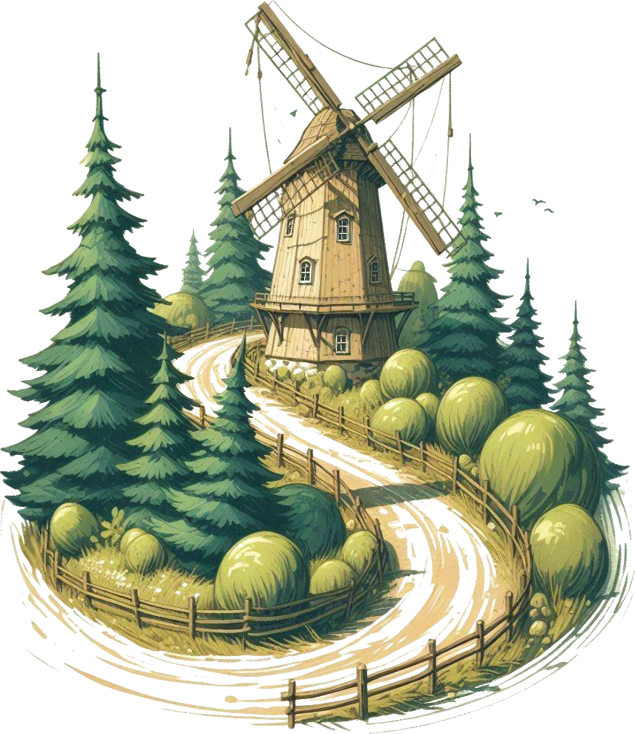

# Title Gradient 6Combats

You will have to control monsters in combats. The book will tell you how to run each monster when the time comes.

Read the following guidelines, but don’t overthink them. They will come in handy later.

## Running Combats

When running combats, try to spread the enemies as evenly as possible on the players (e.g. if you have 4 enemies and 4 players, each enemy should attack a different player). Dying in the first round is no fun!

…unless players want to spread the damage differently (e.g. if the knight wants to front-line and take the damage instead of the mage in the back).

## Battle Maps

Each combat encounter comes with a battle map, which you can find in the Appendix. If you’re playing online, you can use the exact map. If you’re playing on a table with pen and paper, you can draw a sketch of what the battle map looks like.

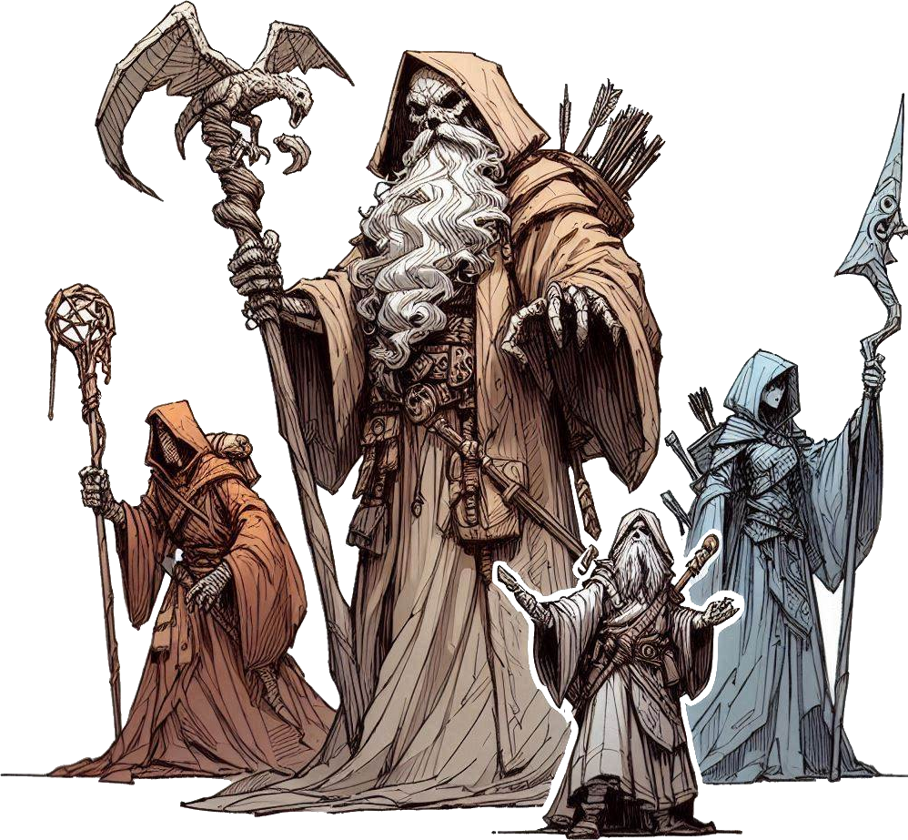You can skip some of the details when drawing (e.g. trees, rocks, etc) unless it specifically says that thing is important to the map.The map annotations are self-explanatory. Diamonds represent player or allied Units (creatures). Blue for players, green for allies, yellow for neutral. Circles represent enemies. Red for hostile, orange for possibly hostile.

## Important: Knowledge is Power

Player knowledge is key to them succeeding in combat. When a monster uses a special Ability, tell the players the exact effect of the Ability.

When the players hit a monster and it has a weakness or a resistance, let them know that their hit was not very effective (or that it was).

You may keep Monster numbers hidden, but make sure you track them (e.g. Health, Stats, etc).

If ever a player wants to know more about a monster, let them roll an Intelligence Check.

Every GM does narrates, tracks and manages combat differently - feel free to use your intuition on how to run monsters, but keep it simple and follow the rules.